Dear Friend and Neighbor:

It’s hard to believe the PSF Community Center is celebrating seven years! We’re excited about our continued growth and contributions to our Oak Square neighborhood and the larger Allston-Brighton community.

This year more than 5,000 children, adults and seniors benefited from the programs and community space available in our building, including:

• Our Intergenerational Literacy program which connects young people and adults in support of reading

• Affordable piano and violin lessons which again have music echoing in the former school halls

• The Farmer’s Market has become a gathering place that provides fresh produce and foods to the neighborhood
through the summer and early fall

• Our partner organizations in the building offer services that meet the needs of individual residents and families,
including affordable daycare and preschool, and services for those in need of basic resources.

And the building itself is something to celebrate – our environmentally conscious transformation of the historic OLP school has been awarded the Gold level of LEED certification!

We’re excited about the momentum we’ve built with your generous support. In the coming year we’ll continue to expand our services, and undertake some needed improvements to our surrounding property. And for that, we need your continued assistance.

Please help by mailing your tax-deductible donation to: Presentation School Foundation, Inc., 640 Washington Street, Brighton, MA 02135 (mailing envelope is enclosed) PSF Tax ID: 14-1910759

Or you can donate online by visiting our website: https://psf.charityproud.org/Donate

Maximize your donation by choosing PSF as your charity of choice on AmazonSmile! https://smile.amazon.com/ch/14-1910759

And if your company has a Matching Gift program you can double your donation. Obtain the application from your company’s HR department, send it to us, and we’ll complete the process!

Your ongoing support will sustain the good work that happens every day in the PSF Community Center. Thank you for helping us strengthen families and our neighborhood!

Sincerely,

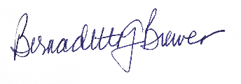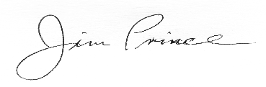
Bernadette Brewer Jim Prince
Executive Director Board President

